# Team Meeting 02/13/24

Project Manager: Wilson

Spokesperson: Muhammed

Visio: Laurell

Project Administrator: Tiffany

Database Analyst: Hedy

It manager: Sarina

Project Coordinator: Irene

Project Web Designer: Bethany

**Company Name: Mediconnect**

[**Mediconnect.pptx**](https://stonybrook365-my.sharepoint.com/:p:/r/personal/muhammad_saud_stonybrook_edu/Documents/Mediconnect.pptx?d=w71e522bafd5b42e08683f5c7020355b2&csf=1&web=1&e=mAeudu&nav=eyJzSWQiOjM5NSwiY0lkIjoyMjQ2ODk2MzY4fQ)

[**https://muhammadsaud123.github.io/han-project-1/**](https://muhammadsaud123.github.io/han-project-1/)

**Slogan:**

Bridging the gaps in medicine one code at a time

**Background:**

ChatGpt:

Mediconnect is a pioneering healthcare technology company dedicated to revolutionizing the healthcare industry. Founded in 2020, our mission is to bridge the gap between patients and providers by leveraging cutting-edge technologies. We partner with leading healthcare institutions like Northwell and Oracle Health to implement innovative solutions that enhance patient care, improve health outcomes, and increase accessibility to healthcare services for all individuals. Our team is committed to advancing healthcare accessibility and inclusivity through technology, ensuring that every patient receives the care they deserve.

**Mission Statement:**

Connecting medicine to your fingertip, our technology eliminates the gap for personalized care.

“Empowering Health, One connection at a time : Mediconnect is your ally in the healthcare revolution. By fusing data and innovation we close gaps and amplify care” - Muhammad Saud

ChatGpt sample: Mediconnect revolutionizes healthcare by leveraging technology to bridge the gap between patients and providers, enhancing care, improving outcomes, and increasing accessibility.

Empowering Health, One connection at a time : Mediconnect is your ally in the healthcare revolution.

MediConnect: Bridging Data, Transforming Care, harnessing, and streamlining healthcare data for better insights and outcomes.

**Vision:**

Mediconnect will continue to strive for excellence as:

As New York’s leading span connecting, as the first choice in bridging, transforming and impacting through harnessing and streamlining healthcare for better information and outcome.

* A pioneering organization, recognized for its innovative use of technology to improve healthcare outcomes and patient experiences
* The go to solution for healthcare providers seeking to enhance their services and bridge the gap between medicine and technology
* A leader in advancing healthcare accessibility and inclusivity through technological advancements
* A trusted partner for patients, providers, and healthcare organizations, committed to improving the quality of healthcare worldwide

Vision statement part 3

Committed to a future where healthcare information is structured and accessible, empowering individuals to make informed decisions for their well-being.

**Profiles**

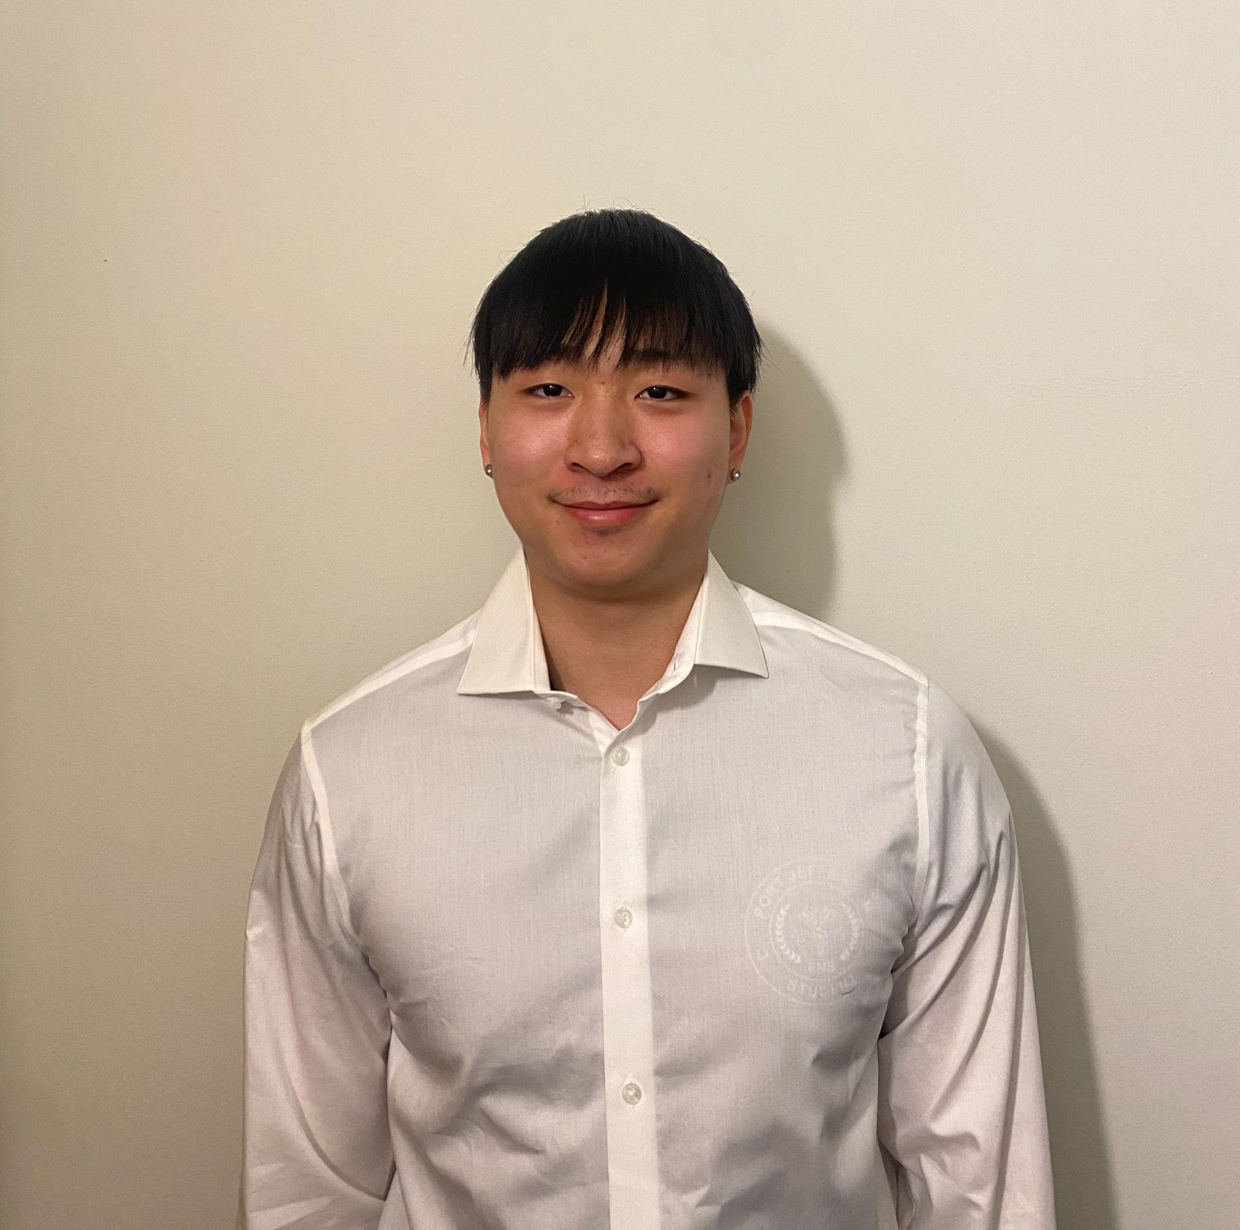

**Project Manager (Wilson)**

Credentials: A Bachelor’s degree in Health Science and Masters in Healthcare Informatics

Graduating and obtaining my masters from Columbia University’s healthcare informatics program, helped kickstart my career as a data analyst intern at Northwell health. Later, worked at NYU Langone Health as a secretary of IT Project Management, Strategy, and Operations. Now, my occupation as a project manager begins at Mediconnect. My role in this company is to plan, execute, and deliver IT projects on time, within budget, and according to stakeholder expectations.

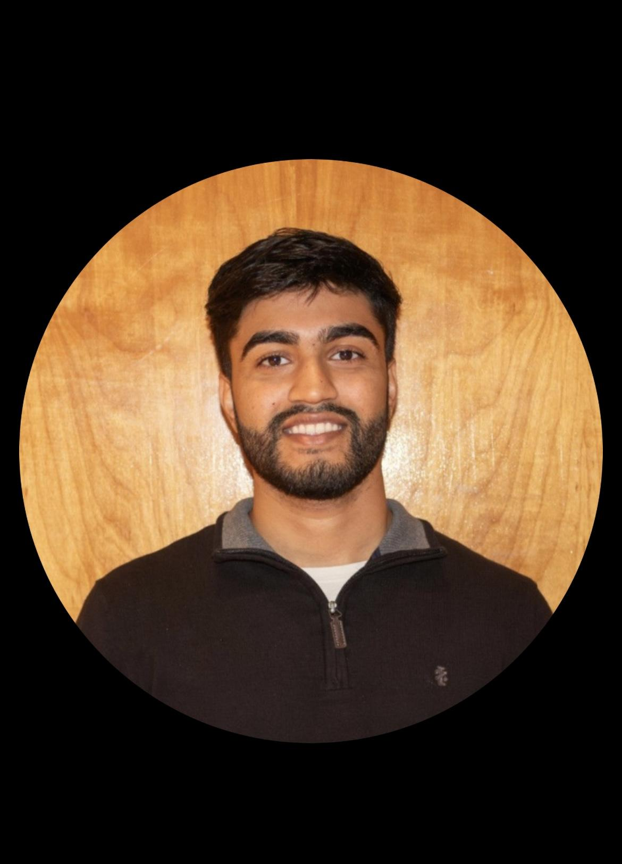

**Muhammad Saud *Spokesperson***

**Credentials** : MD, Harvard Medical School, MBA

Having graduated from Harvard Medical School and also obtaining my MBA from Harvard, my professional journey led me to observe a critical issue within hospitals. Now my role as a spokesperson working for mediconnect involves elucidating how technology can bridge these gaps in healthcare.

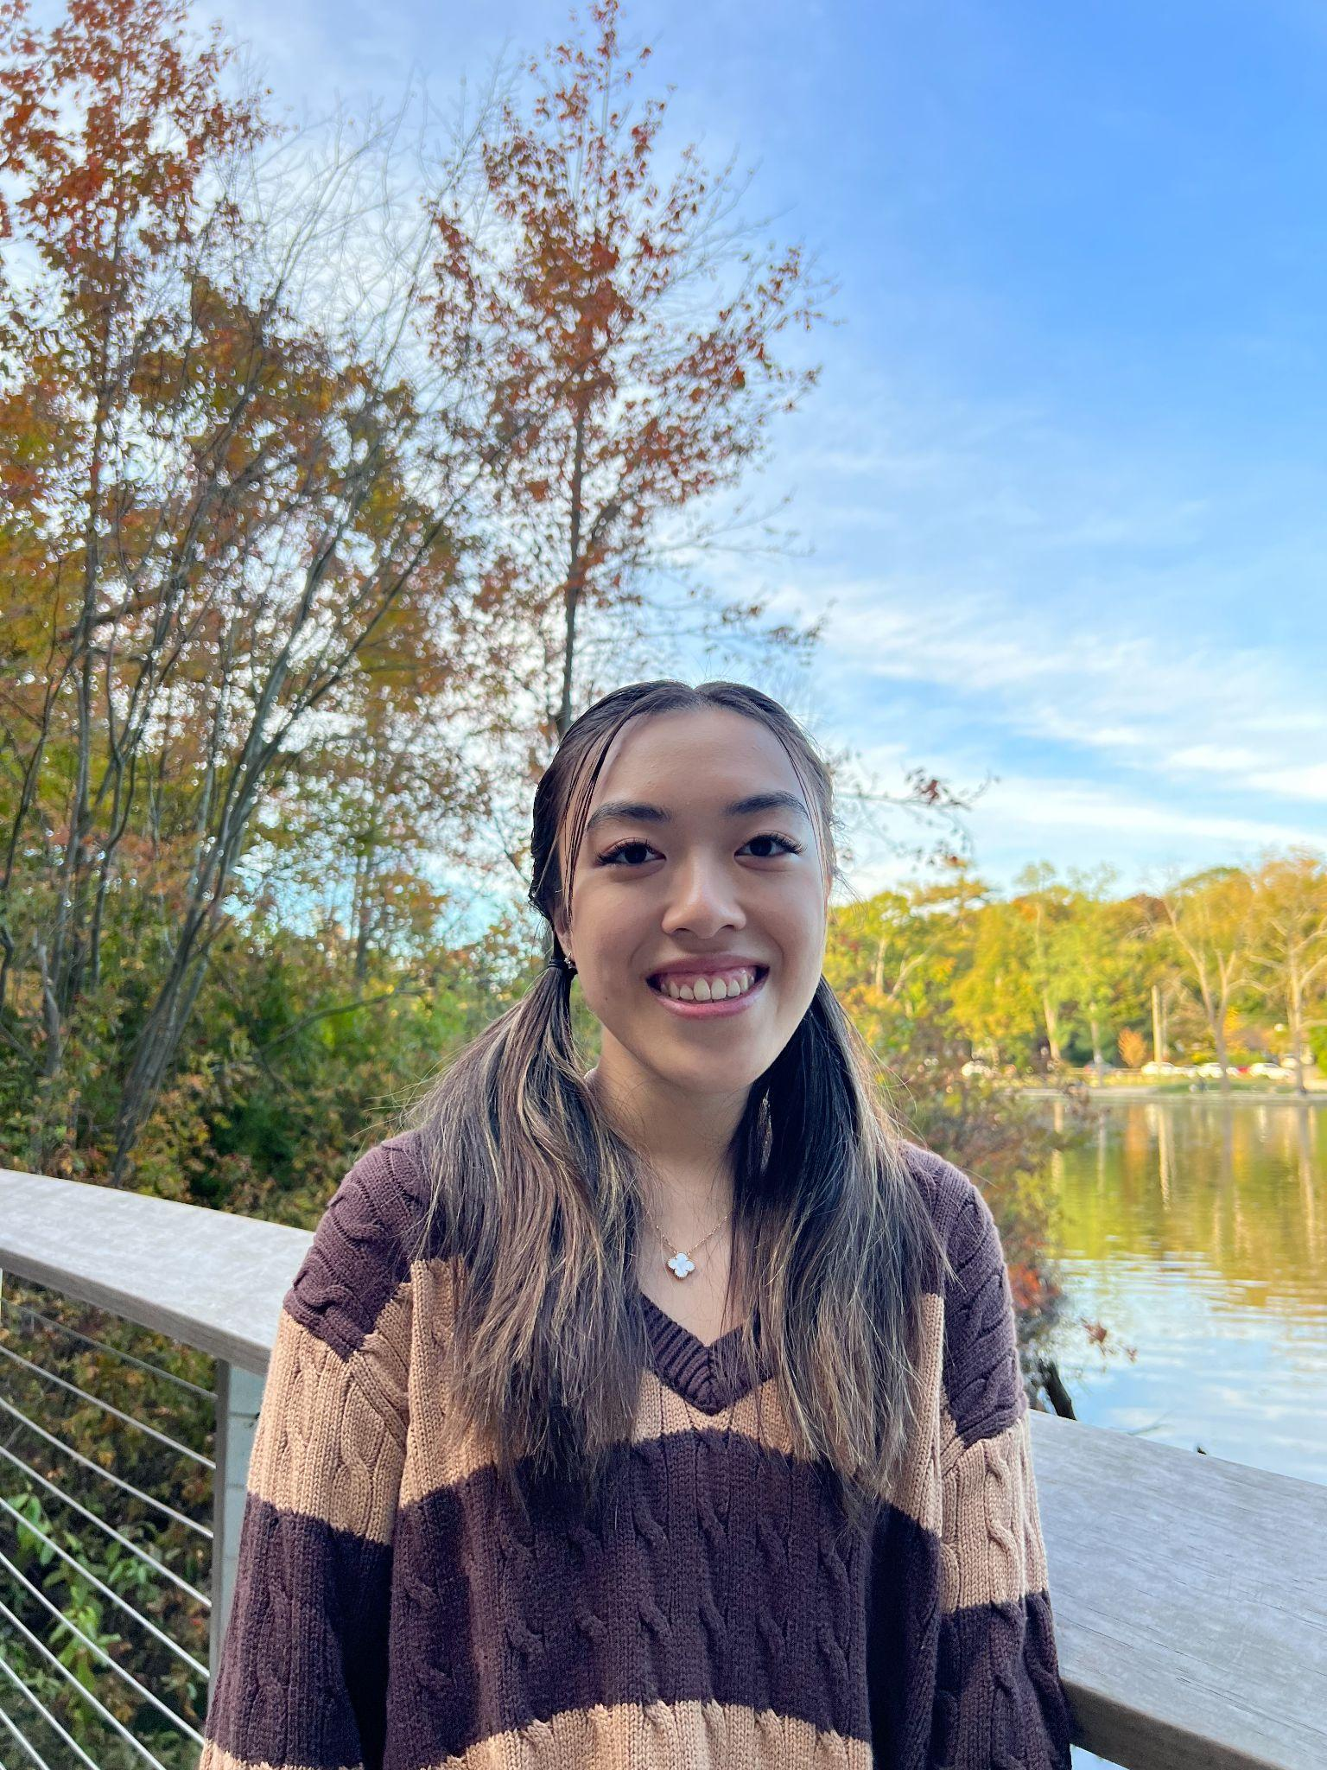

Project Administrator (Tiffany)

Credentials:

Completed Bachelor of Science degree in Business Administration at Columbia and a Master of Arts and Science degree in Systems Engineering at John Hopkins University. Worked as an IT specialist at NYU Langone health. In this role, technology issues were analyzed, troubleshooted, and evaluated. Bring out the highest level of enthusiasm and organization in MediConnect.

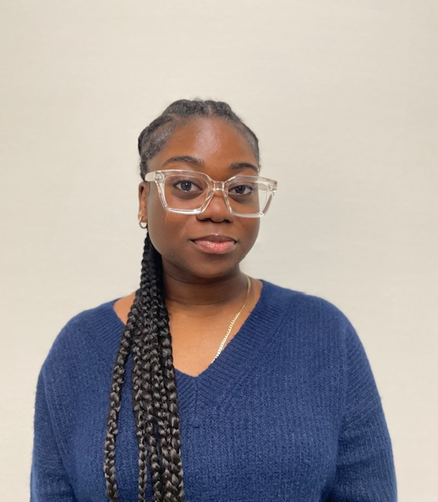

Visio (Laurell)

Credentials:

A Bachelor's Degree in Architecture within the School of Architecture and Planning at The Massachusetts Institute of Technology. Masters in Business Information Technology. Worked for the New York Department of Environment Protections as a Computer Associate and participated in design. Making organization easier for others; with amiable and enthusiasm.

Database Analyst (Hedy)

Credentials: A Bachelor’s Degree in Computer Science from Massachusetts Institute of Technology and a Masters of Business Analytics from Cornell University.

While working towards getting my Bachelor’s Degree I worked as a data analyst intern of Quest Diagnostics. My responsibilities consisted of data collection, cleaning, and analysis under the supervision of experienced analysts. Once I graduated with my Bachelor’s Degree, I became a data analyst at Medtronic. During my time at Medtronic, I felt the desire to further my education so I started getting my Master's degree. At Medtronic, my job consisted of interpreting and analyzing medical data to improve efficiency within the company. After working with Medtronic for 8 years, my desire for a higher position and bigger goal led me to leave the company. As the lead data analyst of MediConnect, I want to utilize my leadership skills and communication skills to make this company as efficient as possible. The results of my work will help other workers access the database more easily, thus improving the service that patients receive.

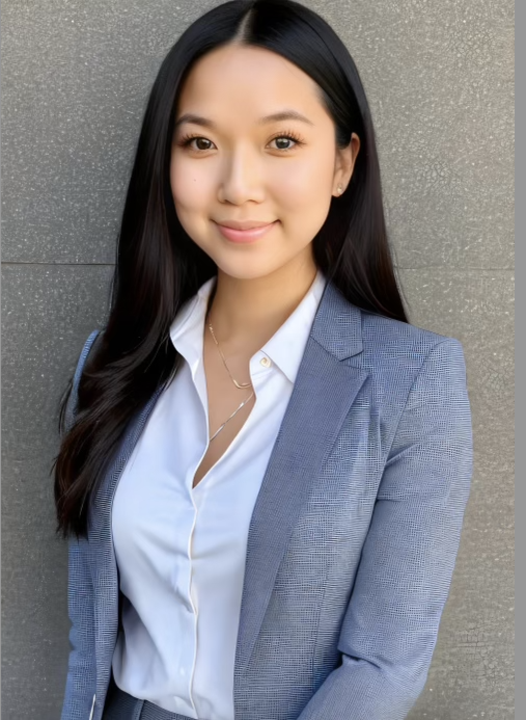

IT Manager (Sarina)

Completed an undergraduate degree in Information Science at Stanford University and a Master’s degree in Information Systems from the University of California, Los Angeles. Worked as a Junior IT Management position at J.P. Morgan & Chase. Worked at Microsoft as an IT Manager before getting promoted to Senior IT Manager. Developed and enforced IT security policies, procedures, and best practices to protect the organization's data and systems.

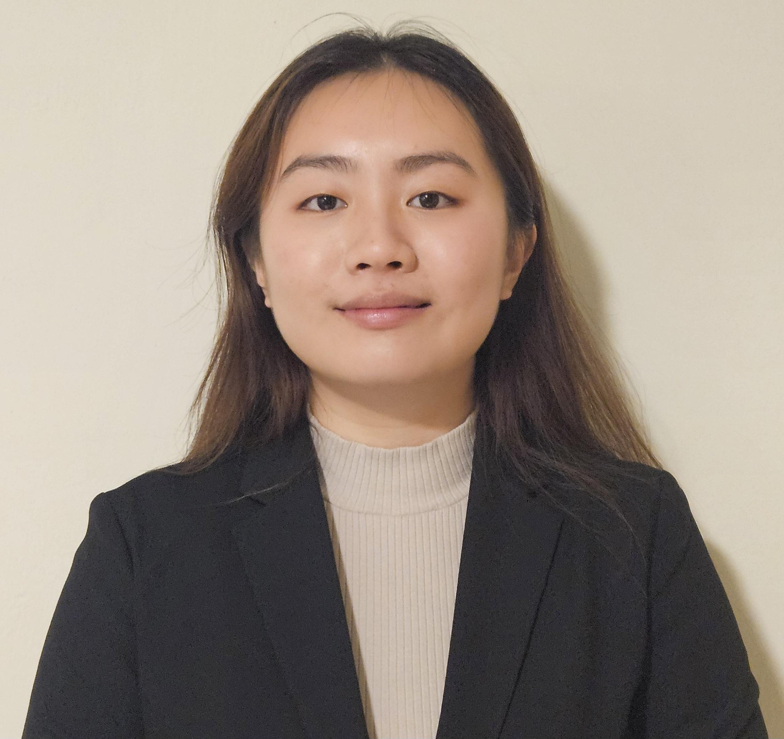

Irene Li Project Coordinator

A Bachelor’s of Science degree in Business Management from NYU and a Master's degree in Business Analytics from Cornell University. Worked as a business management intern at Emblem Health Insurance Company. Worked at Anthem Health Insurance company as a data analyst. Developed business strategies, improving operational efficiency, and analysing trends and risks making sure the project is completed on time and within budget.

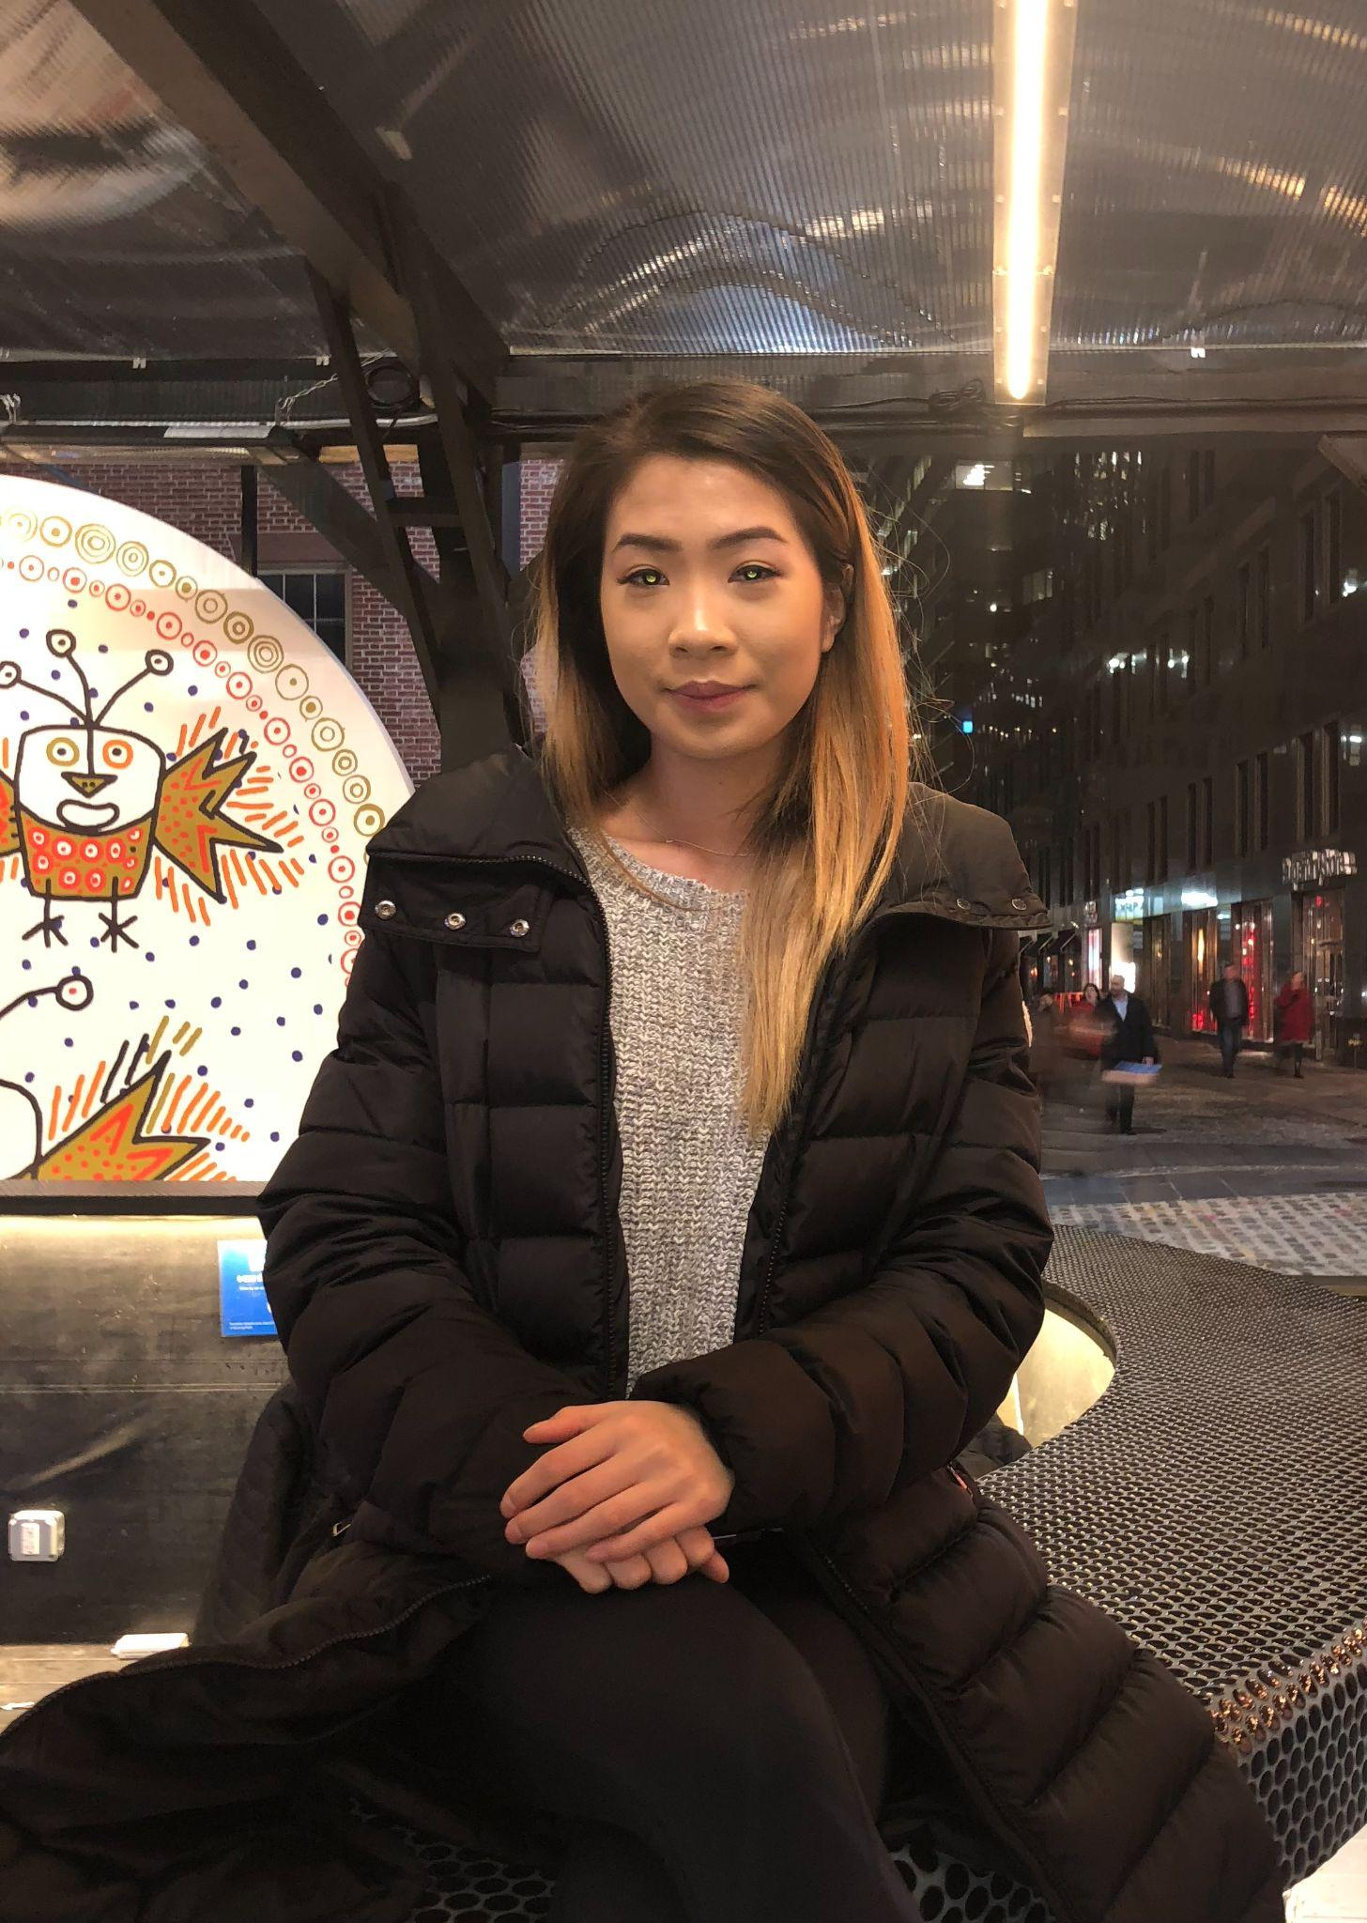

Project Web Designer (Bethany)

Graduated Rhode Island University with a Bachelor’s in Graphic Design and a M.S. in Computer Science from Syracuse. A senior web designer at CureMD Healthcare and at Oracle. Worked on images for product labels, advertisements, and website development. My leadership role alongside duties played a major part in mentoring and supervising my team.